NI miniSystems Pioneer Release

Inspired by customer applications and developed in collaboration with leading educational suppliers, NI miniSystems are small-scale replications of real-world systems that connect with NI educational hardware and software to create engineering and science systems.

NI miniSystems in Pioneer Release allow users in higher education (university/college) to purchase units so they can "ramp-up" on integrating NI miniSystems into courses as soon as they are available. National Instruments collects active feedback from users of NI miniSystems in Pioneer Release to acquire sufficient feedback for suppliers and partners before the next release. NI miniSystems in Pioneer Release are stable but not feature complete and will most likely require the use of custom programming to fully meet customer application needs. For this reason, it is recommended that customers self-qualify to participate in the Pioneer Release by obtaining basic LabVIEW training (LabVIEW Core 1 and 2). Participants have access to standard training discounts that can be viewed at ni.com/training.

myQuake

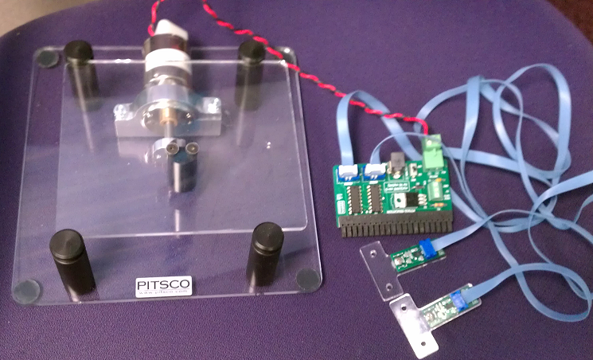The myQuake by Pitsco Education is a motion system with accelerometer measurement and motion control capabilities for NI myDAQ. The system includes a platform that moves from side to side where structures are attached for testing. The myQuake includes two accelerometer inputs that can measure acceleration in the x, y or z axes. This system is the ideal tool for teaching structural design concepts in a hands-on dynamic way. Students can directly control the motion profile and measure the resulting forces on their own student-built structures. This miniSystem can also be used for teaching applications such as resonant frequencies, sensor measurement, and data acquisition and analysis.

The courseware example illustrates the affects of different methods of construction by displaying the detected acceleration at two locations on a structure. The students have the ability to adjust the speed of the table while observing and recording the resulting forces. Students will build structures to meet sets of requirements and constraints while minimizing the affects of externally applied motion.

Analog Input - Accelerometers

1. AI0 is connected to Accel_A
2. AI1 is connected to Accel_B

Accelerometer Truth Table

|  |  |  |  |  |  |  |  |  |
| --- | --- | --- | --- | --- | --- | --- | --- | --- |
|  | **DIO Line Setting**  X = Don’t Care  Gsel: 0 = +/- 1.5g  Gsel: 1 = +/-6g | | | | | | | |
| **Accel_A** | **DO0** | **DO1** | **DO2** | **DO3** | **DO4** | **DO5** | **DO6** | **DO7** |
| X | 1 | 0 | Gsel | X | X | X | X | 1 |
| Y | 0 | 1 | Gsel | X | X | X | X | 1 |
| Z | 1 | 1 | Gsel | X | X | X | X | 1 |
|  | | | | | | | | |
| **Accel_B** | **DO0** | **DO1** | **DO2** | **DO3** | **DO4** | **DO5** | **DO6** | **DO7** |
| X | X | X | X | X | 1 | 0 | Gsel | 1 |
| Y | X | X | X | X | 0 | 1 | Gsel | 1 |
| Z | X | X | X | X | 1 | 1 | Gsel | 1 |

Analog Output

The motor speed is controlled by AO0.

Range: 0-10V

Best results are achieved using PWM control.

Additional I/0 (available on small terminal block)

DIO3 /CNTR

5V supply from myDAQ

GND